Introduction to Kafka

# Kafka scaling and resiliency

## Scaling with Kafka

* Horizontally scalable
  + It can process millions of messages per second.
  + It can handle terabytes of data.
* Scalability features
  + Messages can be spread across multiple topics and partitions. These can be stored and processed in parallel.
  + Kafka brokers can be wired together to create clusters. Brokers in a cluster share the workload of managing and serving messages.
  + Kafka supports multiple concurrent producers and consumers to enable parallel publishing and consumption of data.
  + It also has asynchronous publishing and batching options to reduce latency, as well as network traffic.
  + Consumer groups are another capability that allows consumers to share workloads and scale.

## Resiliency with Kafka

* Storage failures
  + Replication & Mirroring: Kafka supports duplication of data storage using replication and mirroring. This allows it to recover from node or data center failures.
* Broker failures
  + Controller election & Topic leader election: Kafka brokers work together to choose controller and topic leaders among them. When one of them goes down, other brokers quickly work together to choose an alternate broker to execute these functions.
  + Offset tracking: Features like offset tracking and partitioned reassignments help consumers to overcome failures and reprocess data without missing any messages.

Kafka Scaling Concepts

# Clusters and controllers

Central to Kafka's scalability and resilience is its ability to create and manage clusters of brokers.

## Kafka Cluster

A Kafka cluster is a group of Kafka brokers working together to execute Kafka functions. While a single Kafka broker provides all the essential functions, it can only scale and provide resiliency when it can share the workload with other brokers.

Each broker in a cluster has a unique broker ID. It can either be set manually in broker configuration or Kafka can determine it automatically.

The unit of work sharing among Kafka brokers is a topic partition. Brokers are assigned as partition leaders to manage topic data. They’re also assigned to topic replicas to maintain replicated copies of the data. Kafka can thus scale by adding more brokers to manage additional topics, partitions, and data loads.

### How do Kafka brokers in a cluster discover about each other?

They do it through ZooKeeper. Each broker needs a ZooKeeper cluster to work with. When a broker starts, it registers itself under the **/brokers/IDs** node in ZooKeeper. It also discovers other brokers, topics and partition assignments through ZooKeeper.

The ZooKeeper node is an ephemeral node, so when a broker goes down, it is immediately deleted.

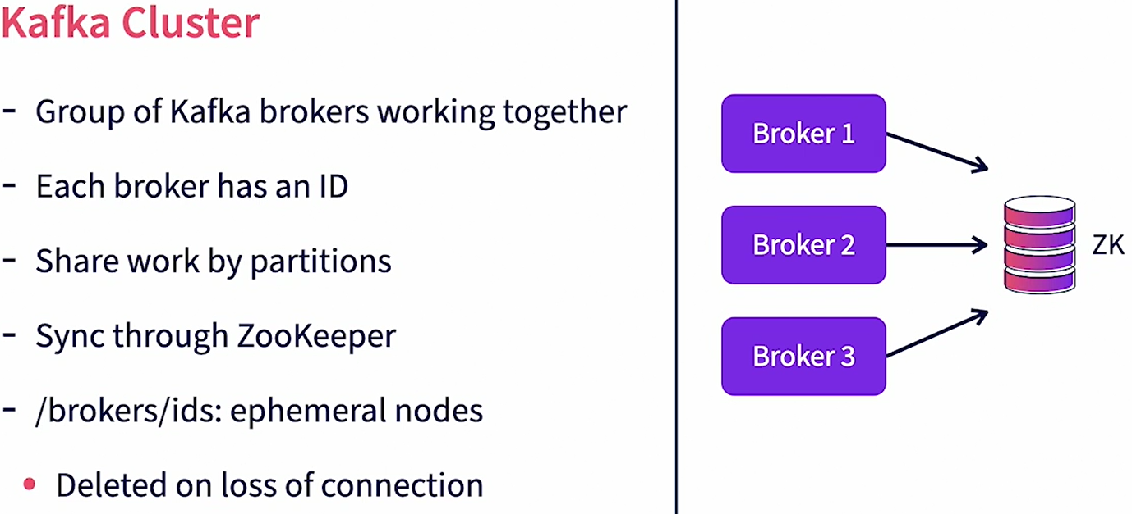

### Who manages all brokers in a Kafka Cluster?

The cluster controller manages all brokers in a Kafka Cluster. A cluster controller is just a broker in the same cluster that assumes additional responsibilities of the controller. A controller is just another broker too, so in addition to controller responsibilities, it will also execute the responsibilities of a regular broker.

### How is a controller assigned in a cluster?

When a Kafka broker starts up, it tries to register itself as the controller by creating an entry under the **/controller** node in ZooKeeper. If the entry has not been created previously, it means that no other controller exists. So this broker becomes the controller. If the entry already exists, it means that a controller is already active. This broker then steps back and starts working with the existing controller.

### What are the key controller functions?

The controller monitors all other brokers whom it discovers through ZooKeeper. If another broker goes down, the controller reassigns the leader partitions and replicas owned by this broker to other active brokers. When topics are created, the controller distributes the partitions and its replicas to brokers in the cluster. It ensures even distribution of load across the cluster. It also manages replicas. When a broker, which is a partition leader, goes down, it promotes one of the replicas on another broker as the leader partition.

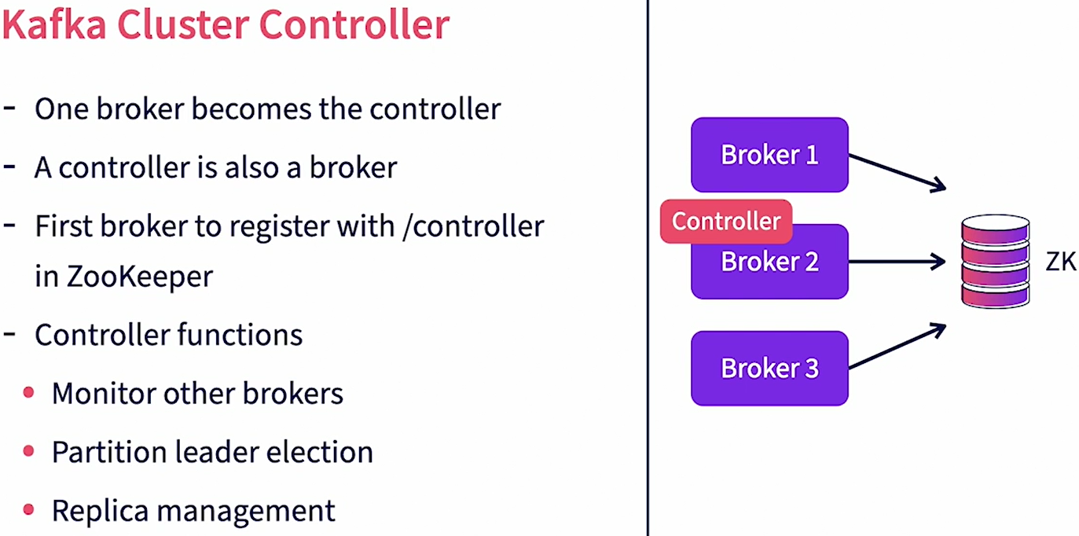

### What if the controller itself goes down? How does Kafka choose a new controller?

All brokers in a cluster subscribe to state changes in ZooKeeper for the **/controller** node. When the controller goes down, its heartbeat to ZooKeeper is lost. So ZooKeeper removes the **/controller** nodes and notifies other brokers of the change. Immediately, all other brokers try to become the controller. The first broker that successfully manages to write to the **/controller** node now becomes the new controller. It then reads all the clusters, brokers, and topics’ information from ZooKeeper and uses it to start managing the cluster. Clusters help Kafka provide scalability and resiliency.

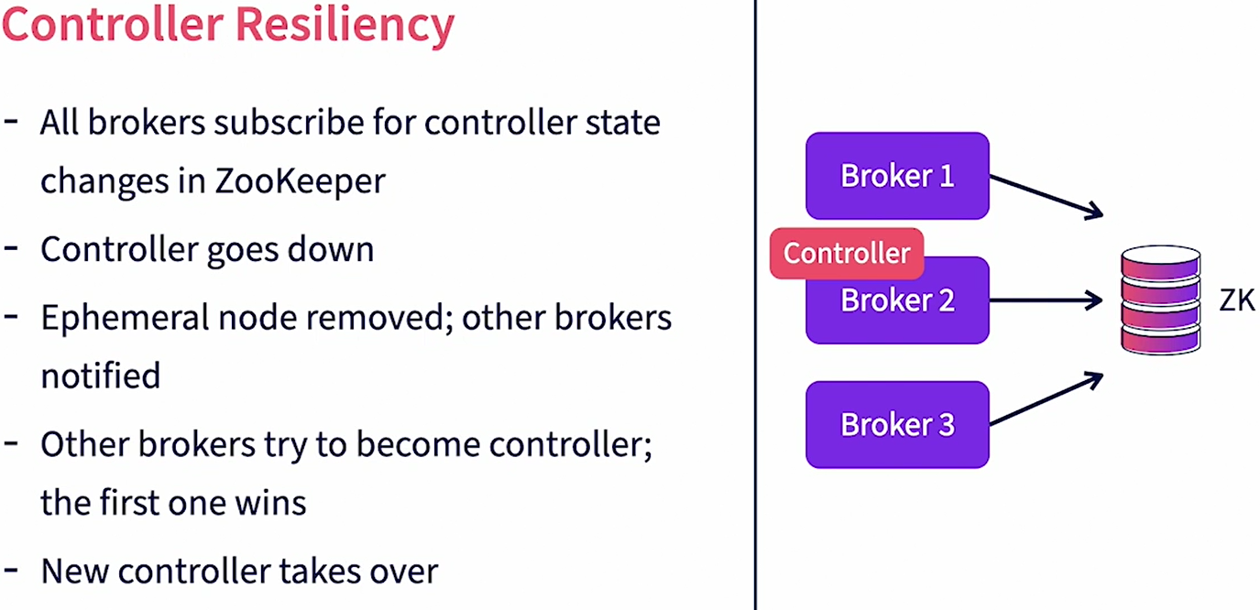

# Replication

Replication is a feature in Kafka that provides resiliency against individual broker failures. Replication works by maintaining multiple copies of individual partition logs across different brokers. The unit of replication is a single topic partition. All messages in a partition are replicated. When a partition is created we can specify the number of replicas needed for that partition. This is set using the parameter **replication-factor.** A partition would always have one leader replica and zero or more follower replicas. Leader replica is the primary copy where all reads and writes happen. Follower replicas are the backups but the primary copy is replicated. The replication factor counts the total copies available including the leader replica. The leader replica is assigned to a leader broker, the leader broker manages all reads and writes for that partition. It also maintains the local log files. Brokers owning replica copies will subscribe to the leader broker to get new messages and update their copies.

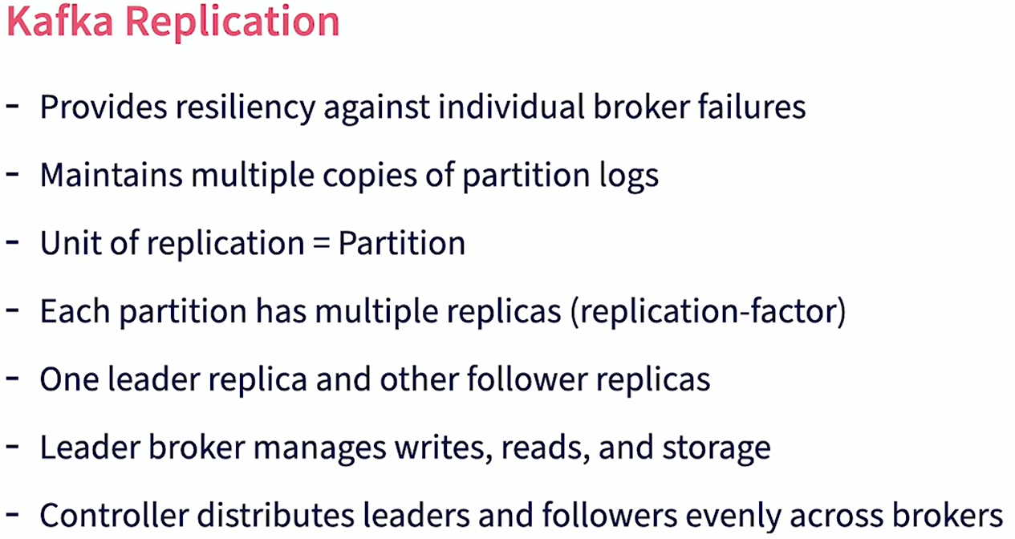

When the topic is created the controller takes care of distributing partitions. It first distributes the leader replicas among the brokers available. If the number of brokers is less than the number of partitions a single broker may get multiple leader replicas for the same topic. Then it distributes the follower replica to brokers such that the replicas are owned by brokers which are not the leader broker. The replication-factor cannot be larger than the total number of brokers available.

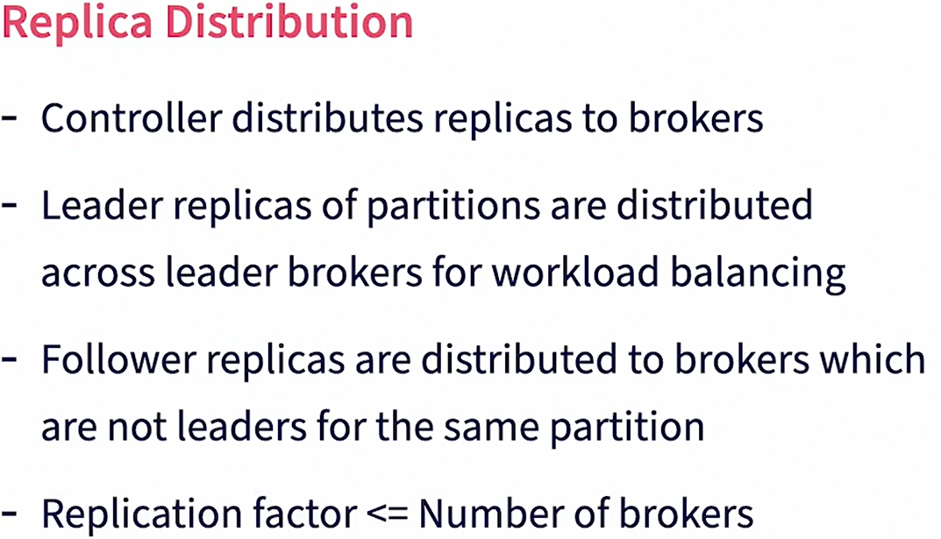

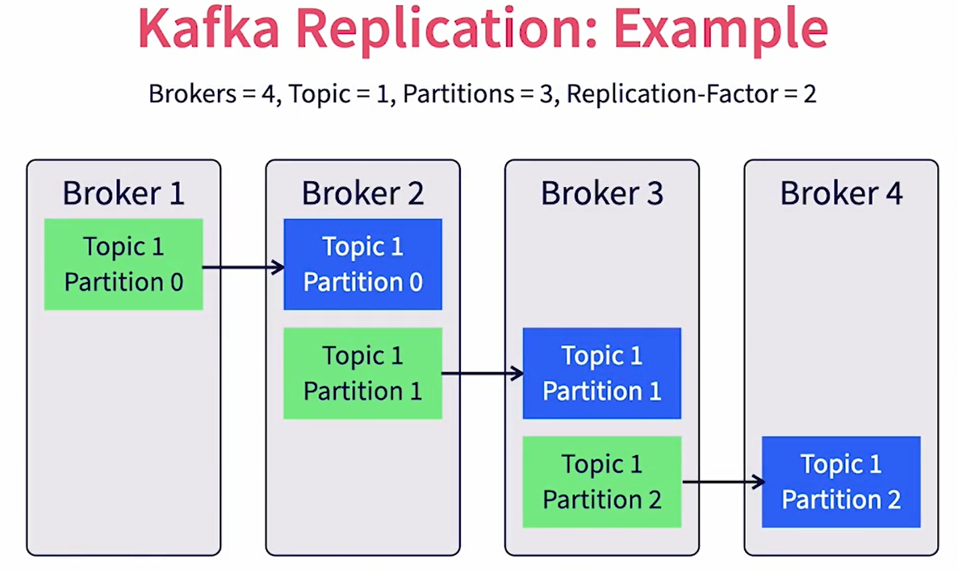

Example:

We have a Kafka cluster with four brokers. We have a single topic which is created with three partitions and a replication-factor of two. In this example, leader replicas are shown in green and the follower replicas are shown in blue. For partition zero, broker one is assigned as the leader replica and broker two gets the follower replica. For partition one, broker two gets the leader replica and broker three gets the partition replica, and so on. The controller ensures that the leader replicas are distributed across brokers for workload balancing. Similarly, it ensures that the follower replicas are distributed across brokers to provide maximum resiliency.

# Partition Leaders

The broker instance that owns the leader replica of a partition is called the partition leader. The controller will assign partition leaders for partitions during topic creation. A Kafka producer, when publishing a message will choose a partition for a message and will send the message to the corresponding partition leader. Similarly, a Kafka consumer will work directly with the partition leader to consume messages in that partition. The partition leader also stored partition data in its log files.

### What about Follower Replicas?

Brokers that own the follower replicas for a partition are called follower brokers. Do note that the same broker can be the partition leader for some partitions and the follower broker for other partitions. Follower brokers subscribe with the leaders for partition data. They keep receiving new messages and will use that to update local copies of their data. Partitioned leadership is evenly distributed by the controller across the brokers in a cluster.

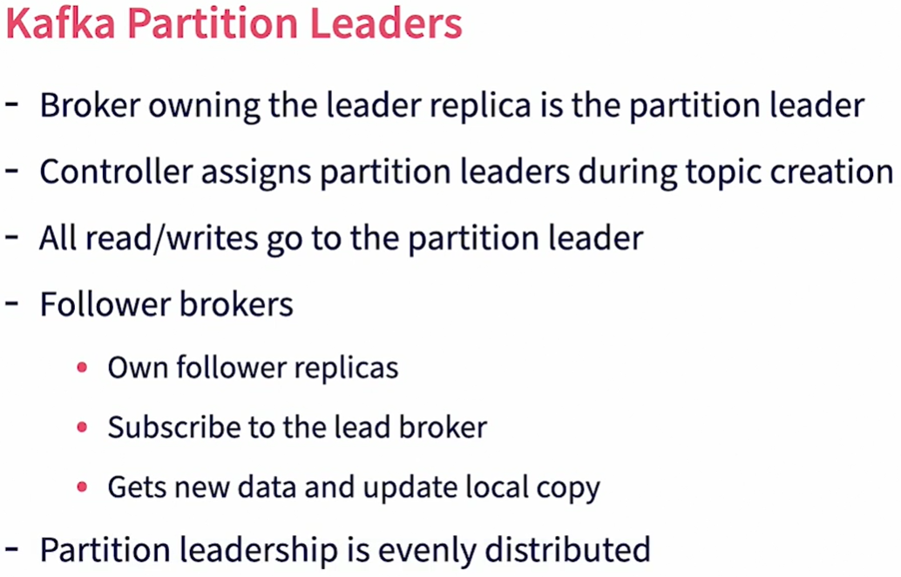

Example

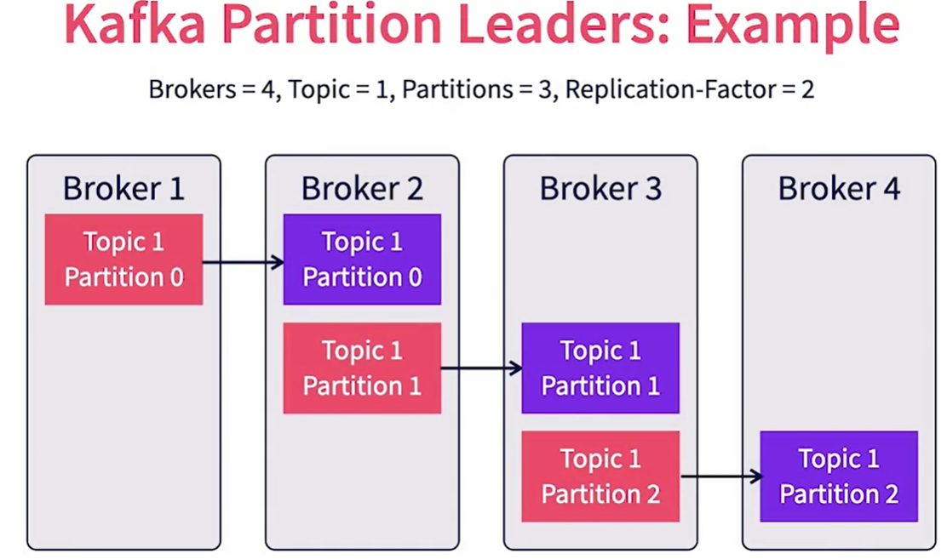

In this case, brokers one, two and three are the lead brokers for partitions zero, one and two respectively. Broker four is not the leader broker for any partition. Brokers two, three and four are the follower brokers for partitions zero, one and two respectively. Given that the **replication-factor** is two, there is only one follower for each partition. Increasing replication-factor will create more followers and hence more redundancy, but at the expense of more work to replicate data.

### How does Kafka take care of ensuring uninterrupted service when a partition leader goes down?

Let’s say that a partition leader for a specific partition goes down. The controller is notified of the lost broker through ZooKeeper, as it keeps track of ZooKeeper changes. The controller will then retrieve the list of all topic partitions for which this broker is the partition leader. Note that this broker can handle multiple topics and their partitions. The controller will then identify the list of in-sync replicas for each partition. An in-sync replica is one that is completely synced up with the partition leader with no messages left to replicate. It will then choose one of the brokers with an in-sync replica as the new partition leader. Again, the controller ensures even distribution of load. The broker chosen as the new partition leader is notified by the controller. This information is also received by the producers and consumers of that partition. The new leader then takes over the read/write operations and the producers and consumers will start talking to this broker going forward. The follower brokers will not start following this leader to keep track of their replicas.

### What happens if a follower broker goes down?

In this case, Kafka will simply mark that replica as out of sync. When the broker comes back up it will catch up with the leader.

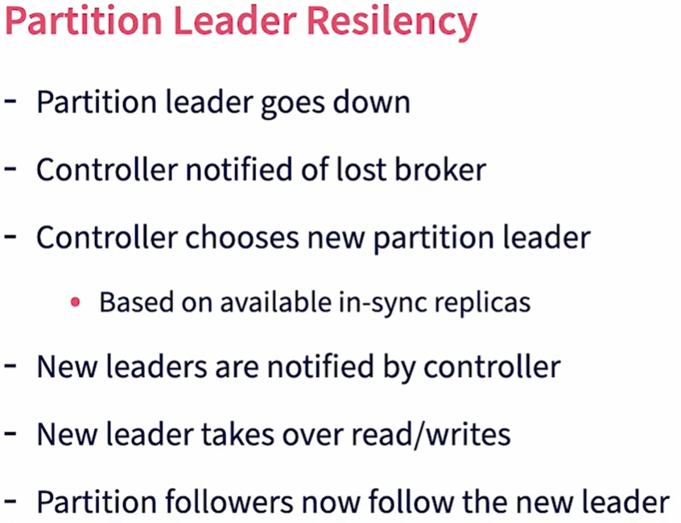

# Mirroring

Mirroring is another option in Kafka that helps with geo-redundancy. Mirroring is an option in Kafka that allows for message redundancy across data centers. While replication works to copy data within a Kafka cluster, mirroring helps to copy data between Kafka clusters. Mirroring provides resilience when the entire primary cluster goes down or becomes unreachable. Mirroring happens between a primary and a backup Kafka cluster and is done using the MirrorMaker tool. Mirroring will replicate all data and metadata in the primary cluster. This includes **topics, topic partitions** and **actual message data.** In addition, information about consumer groups and their offsets are also replicated. So when the primary Kafka cluster goes down, consumers can connect to the backup cluster and continue from where they left off.

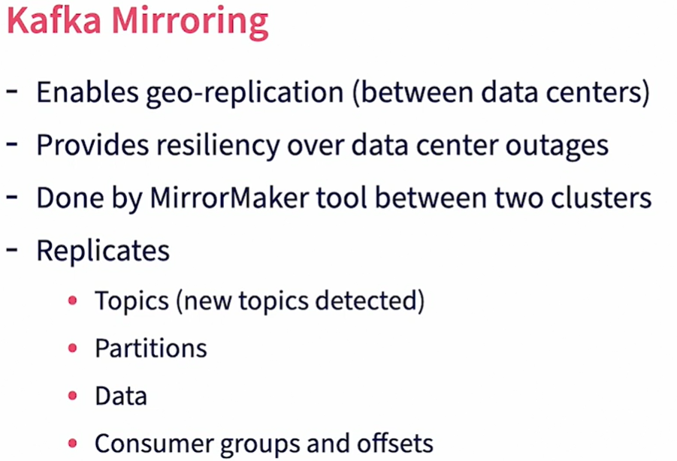

### Let’s now review how mirroring works?

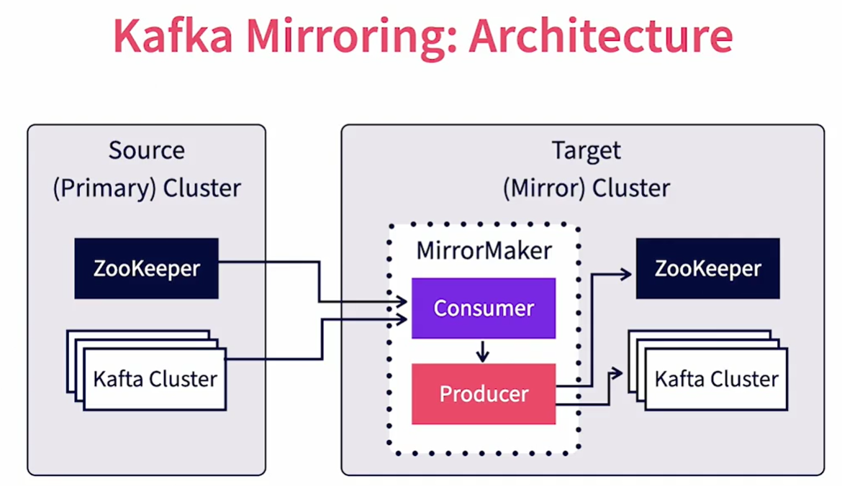

We have two Kafka clusters involved. We have the source or primary cluster set up in a primary data center. We also have a target or mirror cluster set up in the target data center. While both clusters can technically be together in the same physical location, even in the same virtual machine, the true benefit of mirroring materializes only when they are both in physically independent locations. A MirrorMaker tool runs in the target data center. The MirrorMaker tool behaves as a consumer of data for the primary cluster and a producer of data to the secondary cluster. Thus the Kafka clusters themselves don't know about mirroring. The primary cluster treats the MirrorMaker as a regular consumer while the target cluster treats the MirrorMaker as a normal producer. MirrorMaker would consume the messages from the source, then turn around and publish the messages to the target. MirrorMaker will also subscribe to the source ZooKeeper to keep track of topic and consumer group changes and faithfully replicates them to the target ZooKeeper. Note that both the producers and consumers should be aware of both the primary and target clusters and be able to switch from one to the other when connections to the primary are lost.

# Security

One of the requirements for enterprise data processing is ensuring security of data both at rest and in motion. Let's review various security options available in Kafka in this video. Kafka provides client authentication using SSL/SASL. This applies to producers, consumers, other brokers and zookeepers. Kafka provides read-write authentication control by individual topics and consumer groups. Data-inflight can be encrypted using SSL. For at-rest encryption, Kafka does not provide an out of the box solution. It is recommended to use encrypted disks for storage. Kafka security features are basic as it is expected to be used as a messaging system within a trusted network where the producers and consumers are also within the same trusted domain. It's not recommended to publicly expose Kafka through the internet without an API layer. Similarly multitenancy is hard to implement in Kafka as SSL certificate key management by individual tenants and users does not scale. It's recommended to use additional custom layers in the producers and consumers to provide fine-grained security and multitenancy.

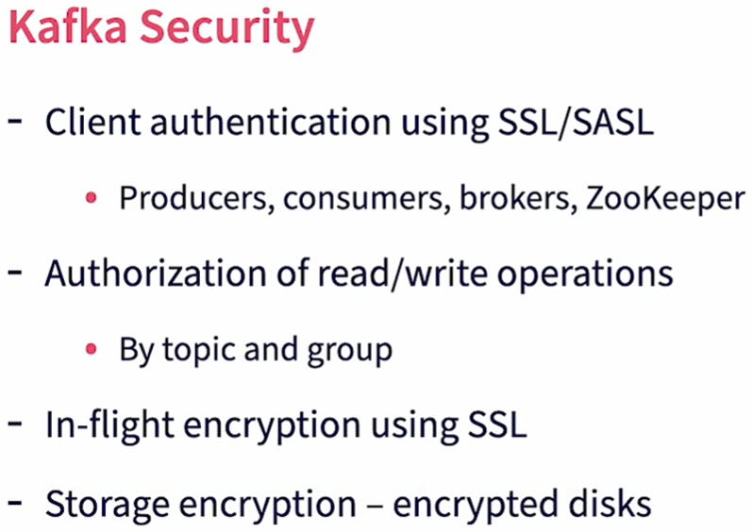

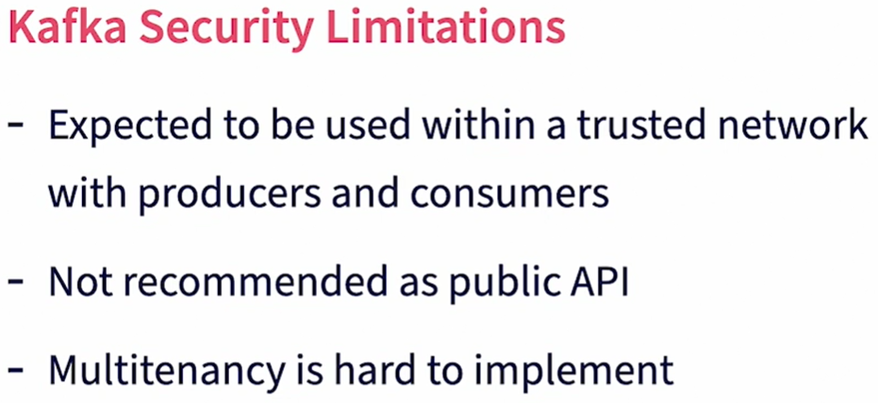

# Producer Internals

The Kafka producer is a client library that is embedded within the client which is usually written in a programming language.

## What happens within the client when it receives calls from the host program?

When a Kafka producer is created by the main program it receives various configuration information, the key among them being the list of bootstrap servers. We need to specify at least one bootstrap server for Kafka. The producer then contacts that bootstrap server and collects metadata. It first collects information about all the Kafka brokers in the cluster. It also receives information about topics, their partitions and partition leaders. It also subscribes to changes in the metadata and keeps track of them.

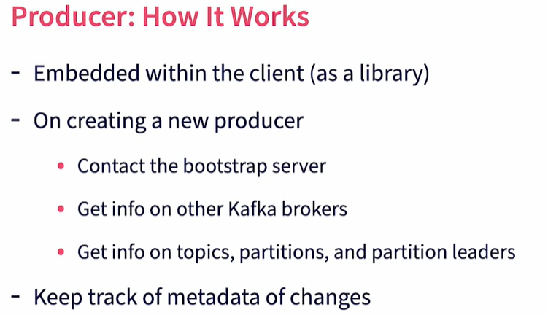

## What happens when the host program sends a producer record to the producer client using the *send* method?

The first thing the producer does is to serialize the message with the key and value serializers set up in the Kafka connection properties. Next comes partition selection. The partition for the message is selected by the producer, not by the Kafka cluster. If the message has the key then the producer will use hash partitioning to identify the given partition. If no key is present, it will use a Round Robin method. Custom partition selectors can also be implemented. The producer maintains a local batch for each partition which is in a memory cache. The message is then added to the corresponding partitioned batch. A separate producer thread is used to push each batch to the corresponding partition leader broker at periodic intervals. This interval is configurable. Then once the partition leader has received and processed the message the producer will receive an acknowledgement which it will pass to the host program.

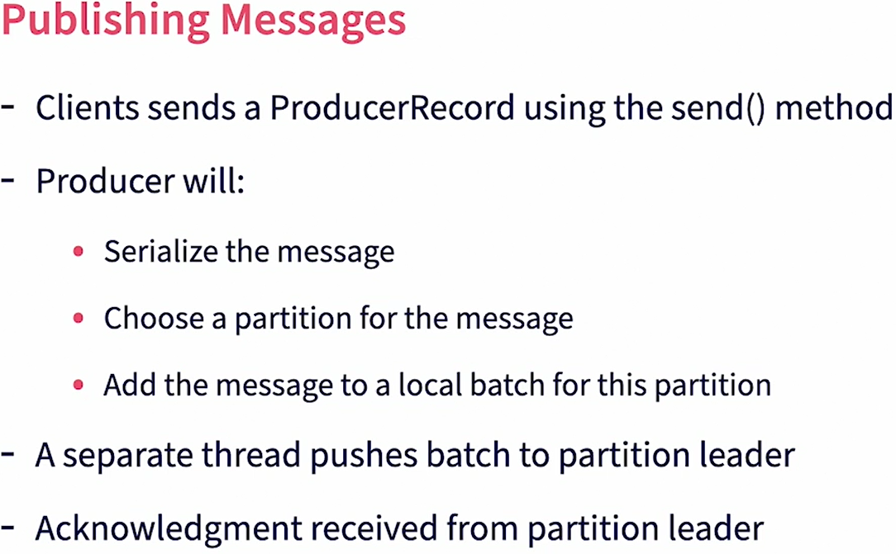

# Producer Publishing Options

There are three producer publishing modes. These three modes provide trade-offs between skill, guaranteed delivery, and error handling.

## Synchronous Mode

The first mode is called a synchronous mode. In this case, the client code sends the message to the local producer. It then waits for the message to be actually sent to Kafka and the acknowledgment receive. The host thread is blocked until the acknowledgement is received. So if there are any errors in sending, the same threat can process the error before moving on to the next message. The call returns a RecordMetaData object which contains information about the partition the message was published to, and the Kafka offset for the message in that partition. This method is simple, ensures guaranteed message delivery, and has the ability to process errors in the same thread. The thread can either try republishing the message or skip the message. Given that it is synchronous, this method is slow as it waits for the network round trip to the Kafka broker which in turn needs to write and replicate the data. It does not explore the batch publishing capability of the producer as it publishes one message at a time.

## Asynchronous Publishing with No-check

The second publishing method is asynchronous publishing with No-check. This is also called the fire and forget method. Here, the client sends the message to the local producer, but does not wait for acknowledgement. The host thread is not blocked, but it moves on to further processing. The local producer caches the message in batches and a separate thread publishes it to Kafka. This method has low latency and scaling from the client side, as the client thread not wait for acknowledgement. But failures are not tracked and retried, so there is the possibility of missed messages in case of network failures.

## Asynchronous Publishing with Callback

The third method is the asynchronous mode with callback. Here, the client sends the messages to the local producer and it also provides a callback function to process results. The client moves on with further processing and does not blocked. The local producer caches and then uses a separate thread to publish the Kafka. When results are returned by Kafka, the callback function is called with the RecordMetaData object, or with the exceptions encountered. It is up to the client now to take action. This has low latency as the client code is not blocked but error handling can get complex, especially if message ordering is needed.

# Acknowledgments in Kafka

## What is a Kafka acknowledgment?

A producer client needs to know if the message has been received successfully and stored by the broker. It is also helpful to know if the message has been replicated so in case of broker failures the message is still available. The behavior of acknowledgements is controlled by the acks parameter set on the producers side during broker configuration. It determines the number of replicas of a partition that must successfully receive the message before the scent operation is declared successful. Do note that the producer only sends the message to the leader partition and then it is the leader partition that needs to propagate this message to the replicas. The more the replicas that are successfully updated, the better is the guarantee that messages have been received and is available even in case of broker failures. But more of the replicas also means more latency in completing the operation as the partition data needs to coordinate with more brokers to complete the operation.

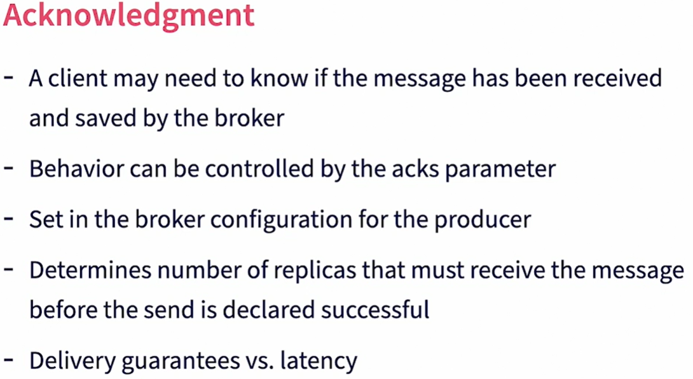

There are three possible values for the acks parameter. Please note that this works in combination with the producer publishing options. A value of zero means that there is no acknowledgement needed. This provides really high throughput but has no message delivery guarantee. A value of one means that the leader replica should successfully receive and store the message. This is the default value. There is an impact on throughput if synchronous mode is used as the publishing thread waits for this acknowledgement. A value of all means that all in-sync replicas should receive the message before an acknowledgment is received. It creates more latency if synchronous mode is used.

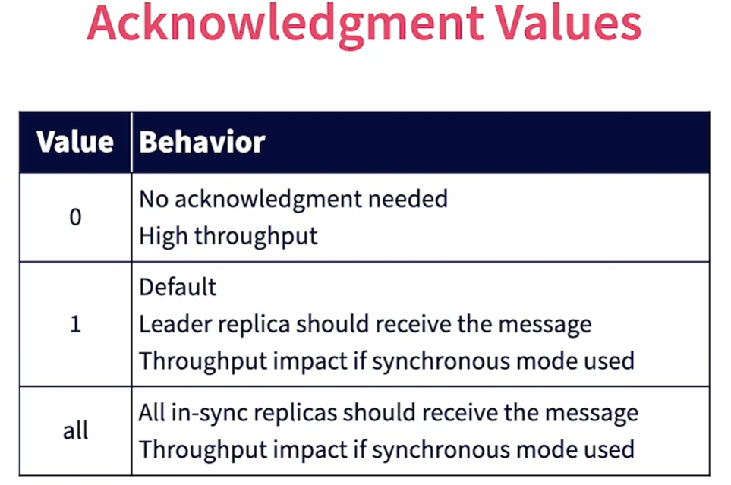

# Additional Producer Parameters

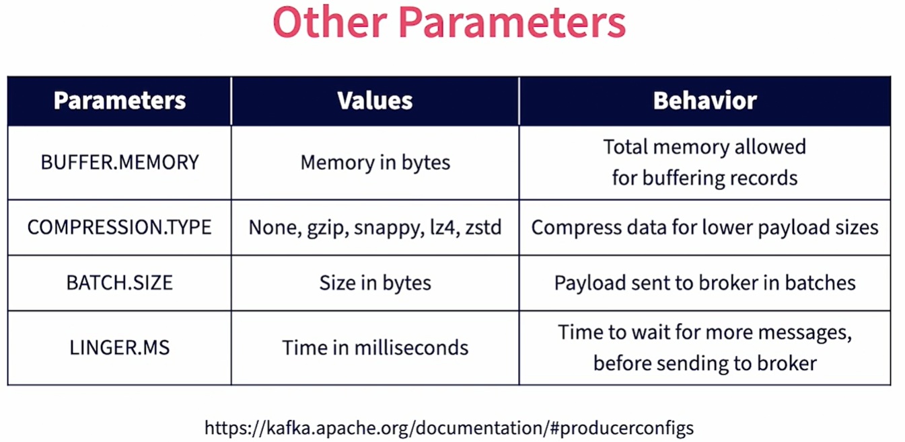

All parameters are set up during Kafka producer creation.

* **BUFFER.MEMORY:** This is the total amount of memory provided on the producer client for caching messages. The more the memory, the higher is the ability to cache.
* **COMPRESSION.TYPE:** This compresses messages that are sent over the wire, resulting in lower payload sizes and lower network bandwidth requirements. However compression has the overload of compressing and decompressing messages. Various options are available here, including gzip, snappy, lz4, and zstd.
* **BATCH.SIZE:** This sets the threshold value of the batch in bytes for a given partition, the producer waits for a batch of messages to attain this size before the batch is sent to the partition leader. This saves on the number of round trips.
* **LINGER.MS:** It is the maximum time the producer would wait for a given batch to attain the BATCH.SIZE that is configured. If this time is exceeded then the batch is sent to Kafka. So, while a batch is being built up there are two thresholds to control when the batch is dispatched. It's either if the batch reaches BATCH.SIZE or if the LINGER.MS as exceeded.

There are a number of additional parameters available. Please review them using the URL shown here [**https://kafka.apache.org/documentation/#producerconfigs**](https://kafka.apache.org/documentation/#producerconfigs).

# Consumers: How it works?

## Group Coordinator

First, let's start with the group coordinator. Kafka consumers are typically part of consumer groups. Each consumer group has a group coordinator associated with it. The group coordinator is a Kafka broker in the same Kafka cluster. The controller designates a group coordinator when a new consumer group is used to access Kafka. The coordinator keeps track of all the active consumers in the consumer group. It does so by receiving heartbeats from the consumer. When the consumer connects to Kafka, it establishes this heartbeat with the corresponding group coordinator. When the heartbeat stops, the coordinator senses that the consumer is down and proceeds to trigger rebalancing of the partitions among other consumers in the same consumer group. Similarly, when a new consumer is added to the group, rebalancing is triggered.

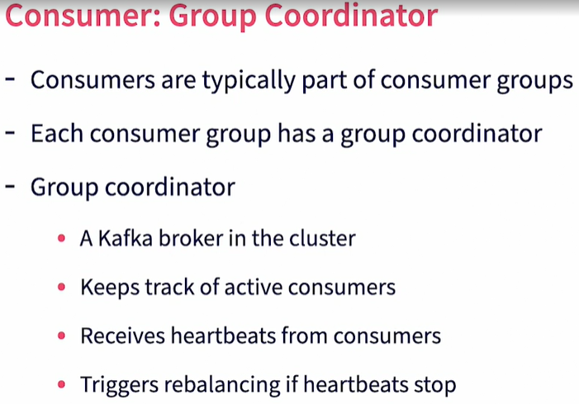

## Group Leader

Each consumer group also has a consumer leader. A consumer leader is a consumer in the same consumer group. Typically, it is the first consumer to join the group. It receives information about all the other consumers in the group, through the group coordinator. It is responsible for assigning partitions to all consumers in the group. It works with the group coordinator for rebalancing. When the group coordinator sees a new consumer being added or an existing consumer going down it requests the group leader for reallocation of partitions. This is then propagated to the individual consumers and they start listening on that new set of assigned partitions. When the group coordinator or the group leader themselves go down, that responsibility is transferred to other brokers and consumers in the group, respectively.

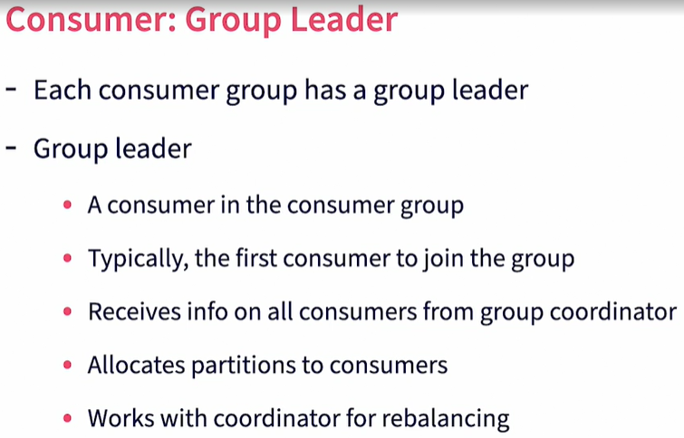

# Batching Message Consumption

Consumers Poll Kafka periodically for new messages. The poll interval is configurable through the poll method. Each consumer is allocated a set of partitions to work with. Consumers poll corresponding partition leaders for new messages. When consumers poll, a batch of messages are returned from Kafka when new messages are available. The bigger the batch sizes and higher the poll interval, the lower or the round trips and request overloads. However, such large sizes and poll intervals, directly impact the latency of processing also. It is required to choose the right parameters based on the use case to balance between round-trips and latency.

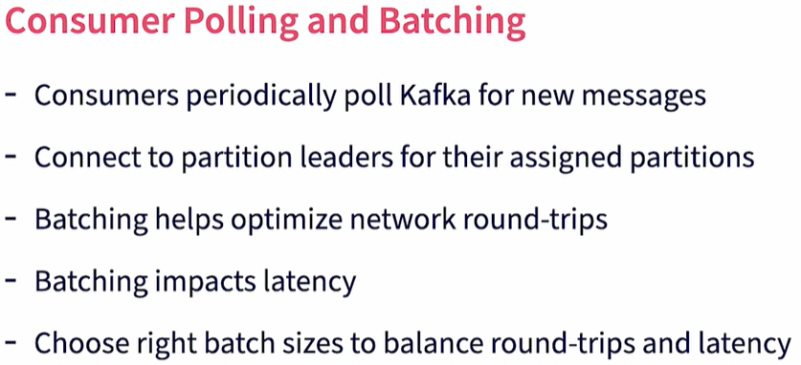

## How do we configure this round-trip behavior?

Here are some key parameters:

* **Poll Interval:** The first one is the poll interval, which is the time between consecrated polls by the consumer to Kafka. This is configured through the poll method.
* **FETCH.MIN.BYTES:** The minimum batch size is configured through the FETCH.MIN.BYTES parameter. A batch should reach this size before the batch is delivered to the consumer. The default sizes, one byte.
* **FETCH.MAX.WAIT.MS:** FETCH.MAX.WAIT.MS parameter, works together with the FETCH.MIN.BYTES parameter. It is the maximum amount of time to wait for the batch to attain the required batch size after which the batch is sent anyway. So when a new poll is done by the consumer and new messages exist in Kafka, the batches send either on achieving the FETCH.MIN.BYTES value or the time lapses for FETCH.MAX.WAIT.MS.
* **MAX.PARTITION.FETCH.BYTES:** MAX.PARTITION.FETCH.BYTES is another parameter that controls the maximum amount of data that is returned in a single batch. This allows to control the amount of buffer needed on the consumer side to store and process the batch received.

<http://kafka.apache.org/documentation/#consumerconfigs>

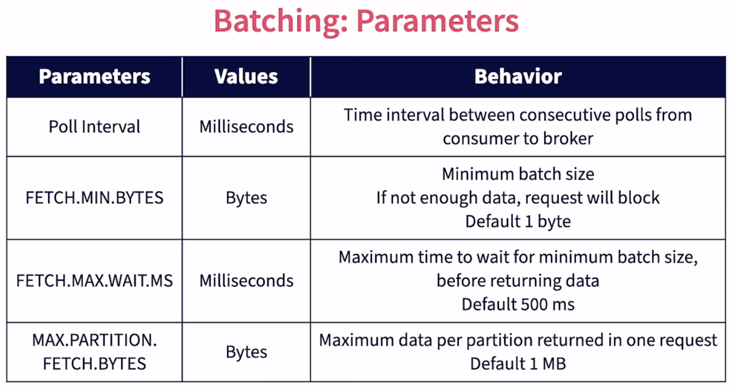

# Committing Messages

By default, consumers are configured to auto-commit messages on receipt. When a message is committed by a consumer in a consumer group, Kafka marks that this message has been delivered to this consumer group and does not send the message again to a consumer in the same consumer group. It is controlled by two parameters. The **enable.auto.commit** parameter determines if it is automatically committed on receipt or if the consumer needs to manually commit. By default, this is set to true. Also the **auto.commit.interval.ms** parameter, determines the interval at which the consumer auto commits messages. The default is 5,000 milliseconds. This means the consumer auto-commits messages received every five seconds. If the consumer commits to receiving messages, it does not guarantee that the consumer has successfully processed the message as processing may involve a number of steps on the consumer side, based on the use case. If the consumer dies after auto-committing a message and before processing, the message will never be received again by a consumer in this group so it will never be processed. Manual committing of a message after successfully processing would mean that if the consumer does go down after committing the message, the message would again be delivered to a consumer in this consumer group and will get a chance to be processed again. Handling duplicates is much easier than handling missed events. Determine if auto or manual commit is needed based on your use case.

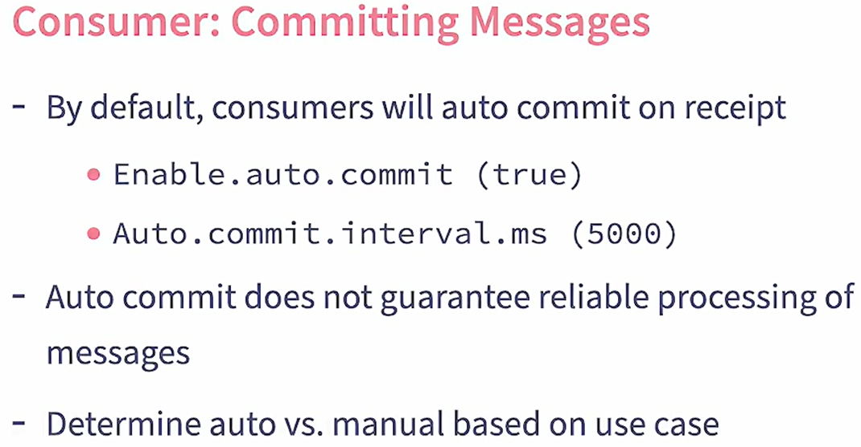

## How does manual commit work?

There are two options available, synchronous and asynchronous. Synchronous commit is done by calling the **commitSync** method on the consumer. This is done after processing every batch, after all messages in the batch are processed. When using the synchronous commit, the thread blocks until all commits are successfully performed by the brokers. There are additional options available to control commits at a message or partition level. In case of asynchronous commit, it is done again at a batch level by calling the **commitAsync** method. In this case commits happen in a separate thread and do not block the main thread. This method can have an optional callback to handle any errors.

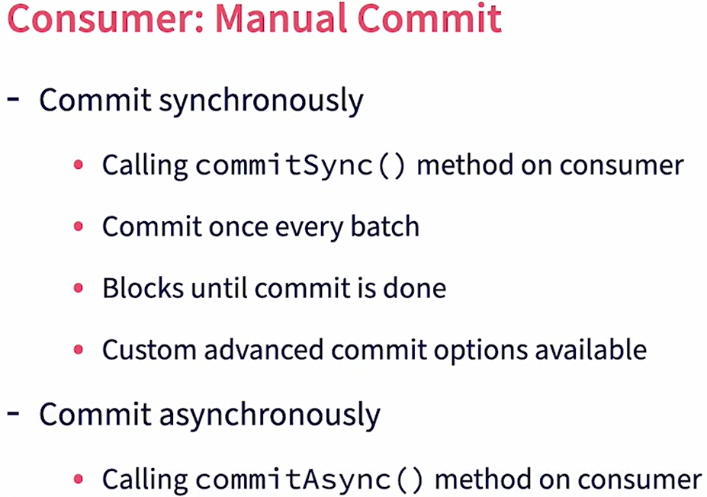

# Managing Partition Counts

In this section, we will focus on managing partitions. One of the most important and difficult decisions to make while creating a topic, is deciding on the number of partitions. Partition counts cannot be changed after topic creation. So care should be taken in choosing the right size. If the number of partitions are too little, then fewer brokers are involved in handling the topic and there is a lot of serialized processing happening. As a result, there could be producer lag and consumer lag. Some brokers and consumers maybe overworked handling big partitions while others may be starved for work as they don't have any participants assigned to them. On the other hand, if the number of partitions is too high, it results in more broker resources like file handles and memory. Note that there is an overhead with each additional partition and the number of partitions a broker can handle is limited. There is also high replication overhead if the number of partitions are high.

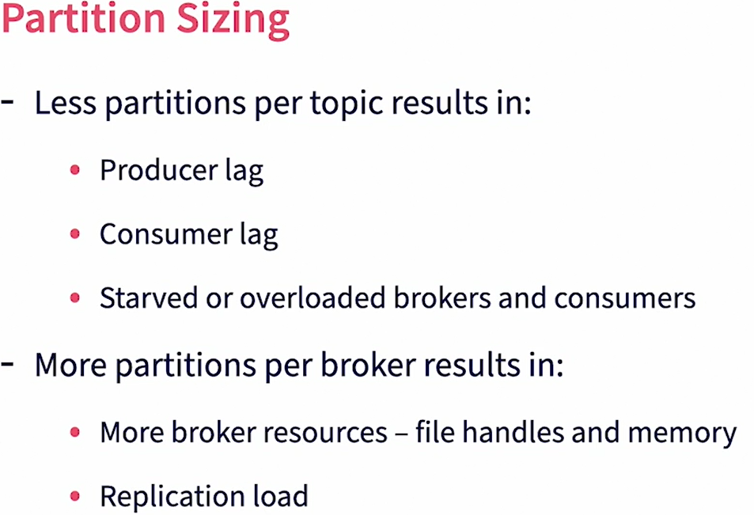

## So what are some of the recommendations for partition sizing?

Plan partition counts before creating the topics as it is not possible to change them later. Make sure that the partition count is greater than the expected number of consumers in the consumer group. Otherwise there will be consumers with no partition to work on. Use as many brokers as possible in the cluster as both partition leaders and replicas. This helps distribute work across the cluster. Also note that brokers have limitations in how many applicants they can handle, including leaders and followers. Try to keep the total number of replicates per broker to be less than 1000. If needed, increase the number of brokers. Messages are distributed among partitions based on keys. So the total number of possible unique values for the key should be greater than the number of partitions. Otherwise, some partitions will receive no messages. It is also important to make sure that the key values are evenly distributed so all partitions get an equal distribution of messages. Finally, it's important to perform load testing to understand the performance characteristics of your specific application and then choose the right sizes for partitions based on overall peak load and observe partition lags.

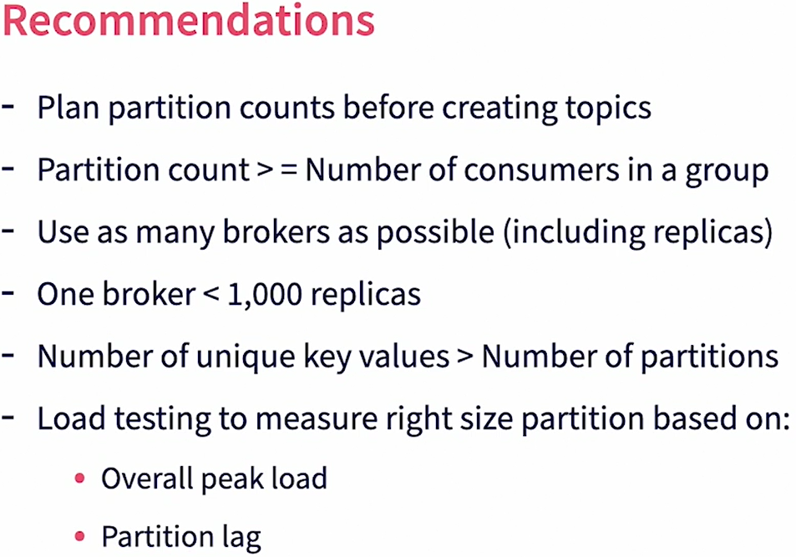

# Managing Messages

Kafka has a limit on the size of messages. Keep the message size small so they are easier to manage. Do not include blobs in messages, rather save the blobs in a central store like S3 and then include the link to the blobs in the messages. Try to use binary standards like Avro for messages. Kafka has serializers and deserializers for Avro messages which can be exploited. Also use a schema repository to share the message schema between the producers and consumers. This also helps in message versioning. One key aspects of messages are messages keys. Choose keys that have more unique values. The more unique values are there better is the partitioning of data. Also choose keys where the unique values of the keys are uniformly distributed. This again will ensure better partitioning of data. Keys do have an overhead in Kafka. Use keys only if message ordering is needed by the key. Without keys, Kafka will use Round Robin method to evenly distribute the messages to partitions.

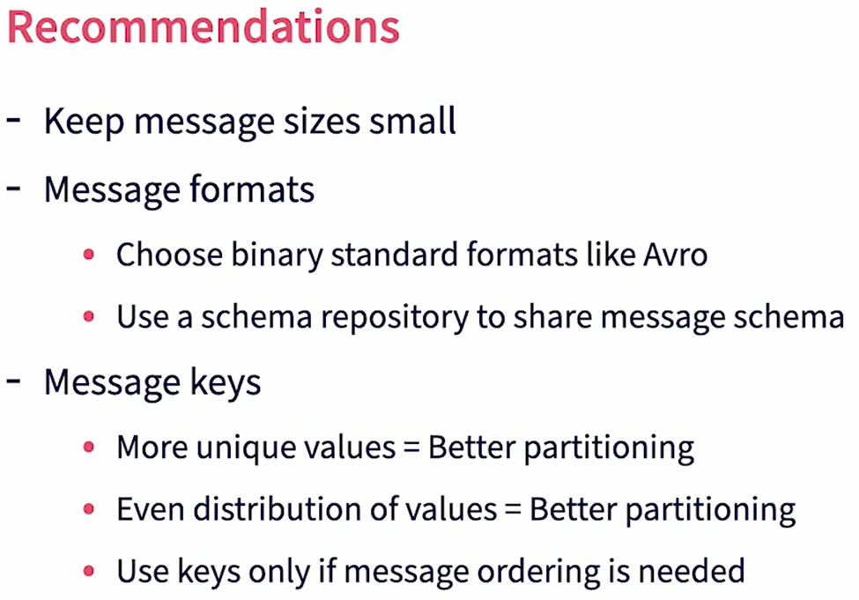

# Managing Consumer Settings

Consumer groups need to scale to match processing loads. Choose sizes based on the expected incoming messages and desired latency. We can also add new consumers to the group when we need additional capacity. Batching is an important consideration for consumers. If you're using it for batch processing, use larger batch sizes to reduce network round-trips. On the other hand, if you're using it for real-time stream processing, use smaller batch sizes and smaller polling intervals to minimize latency. Unless the consumer operations are simple and quick, use manual commits to ensure reliability of data processing. Also provide provisions for reprocessing of messages when they are received again by another consumer in case of failures. Use non-blocking processing and multi-threaded processing for higher throughput on the consumer side. Always test for failure conditions like a consumer going down or a broker going down, and make sure that the messages are not lost and reprocessing happens as desired by that use case.

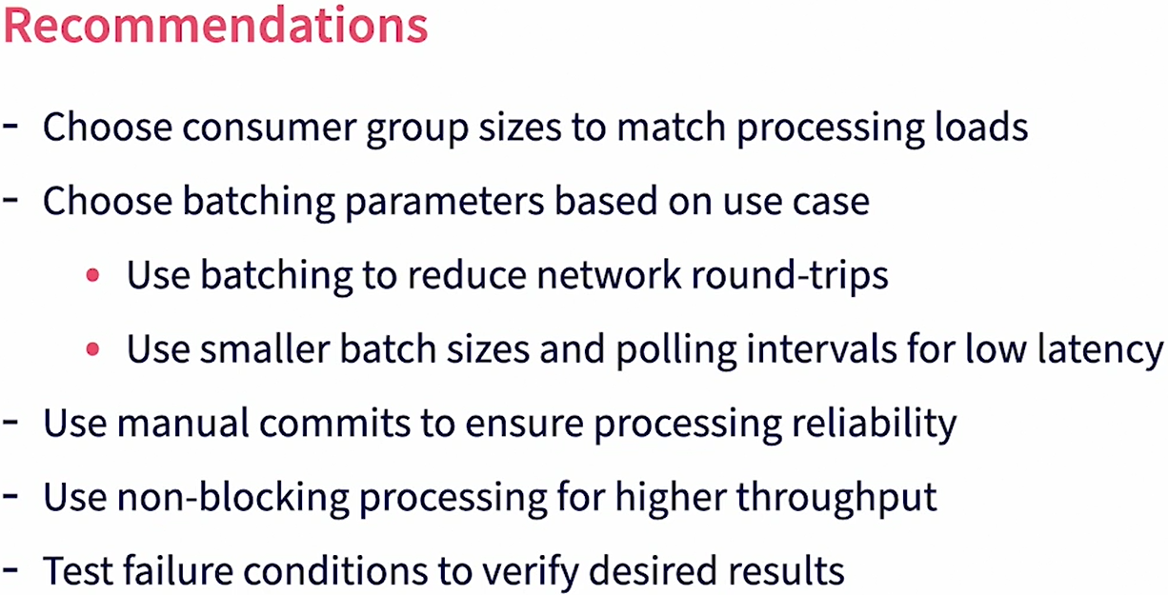

# Managing Resiliency

Use topic replication to safeguard against broker failures. It's recommended to have a replication factor of at least three to maintain safe replicas. Distribute Kafka brokers across different racks. Kafka is recover and will distribute replicas so that they are on different racks. This protects the cluster against rack failures. Use acknowledgements in producer to ensure guaranteed delivery of data to Kafka. Similarly, use manual commits in consumers to ensure that the offsets are incremented only after data is successfully processed on the consumer side. ZooKeeper is the central data store in Kafka. Use a cluster for ZooKeeper also to protect against ZooKeeper failures. It's recommended to install a ZooKeeper node in each of the Kafka broker hosts for speed and resiliency. Use mirroring with Mirrormaker, if geo-redundancy is required. Always test for resiliency test cases to make sure that the system recovers as desired by the use case when failures happen.

# Next Steps

<https://kafka.apache.org/documentation/streams>

<https://flink.apache.org>

<https://spark.apache.org>